Bule hora university


COLLEGE OF INFORMATICS
DEPARTMENT OF SOFTWARE ENGINEERING
3rd YEAR 1st SEMISTER Software Engineering Tools and Practices
Title: Library Management System

Group member id number
1.Gelano Lema………………….RU0196/16
2.Gosa Dabi………………………RU0581/16
3.Musa H/Jemal………………..RU0059/16
4.Rahel Mamushet………..….RU0385/16
5.Bonsa Mohammed…………RU0187/16
6.Yoftahe Yohanis…………...….RU0106/16

Submitted to mr.Getahun F.
Bule hora Ethiopia

1. Introduction
1.1 Background of the Study
Libraries play a crucial role in academic and research environments by providing access to books, journals, and digital resources. Traditionally, library operations such as book registration, borrowing, returning, and catalog management have been performed manually. This manual process often leads to errors, data loss, inefficiency, and difficulty in tracking borrowed materials.
A Library Management System (LMS) aims to automate these processes to improve record accuracy, reduce workload, and provide faster service.
1.2 Problem Statement
The existing manual library system faces several challenges:
- Difficulty in tracking borrowed and overdue books
- Time-consuming registration and searching
- Risk of data loss and human error
- Inaccurate record-keeping
- Inefficient management of fines
1.3 Objective of the Project
General Objective
To design and develop an automated Library Management System that simplifies library operations.
Specific Objectives
- To allow librarians to register, update, and manage books easily
- To automate the borrowing and returning of books
- To provide a search function for quick book retrieval
- To track overdue books and calculate fines automatically
- To maintain secure records of members and transactions
1.4 Scope of the System
The LMS includes:
- Book management
- Member management
- Borrow/return system
- Search functionality
- Fine calculation
Not included:
- e-book reader integration
- Multi-library synchronization
- Online payment services

2. System Analysis
2.1 Domain Analysis
Domain Analysis is the process of studying the domain (library operations) to identify key concepts, entities, operations, and relationships. It helps in designing a system that reflects real-world requirements.
In the context of a Library Management System, domain analysis focuses on how books, members, librarians, and transactions interact.

1️⃣ Purpose of Domain Analysis
- To understand the problem domain before designing the system.
- To identify common entities, attributes, and operations in the library domain.
- To model relationships between objects (like book borrowing, returns, and fines).
- To ensure the system meets functional and non-functional requirements.

2️⃣ Key Entities (Classes)
a) Book
- Represents the items in the library.
- Attributes:
  - bookID, title, author, ISBN, category, status (available/borrowed)
- Operations:
  - addBook(), updateBook(), checkAvailability(), searchBook()
b) Member
- Represents library users.
- Attributes:
  - memberID, name, email, phone, membershipDate
- Operations:
  - register(), borrowBook(), returnBook(), viewHistory()
c) Librarian
- Manages library operations.
- Attributes:
  - librarianID, name, username, password
- Operations:
  - manageBooks(), manageMembers(), issueBook(), receiveBook()
d) BorrowRecord
- Keeps track of books borrowed.
- Attributes:
  - recordID, memberID, bookID, issueDate, dueDate
- Operations:
  - createBorrowRecord(), updateBorrowStatus()
e) ReturnRecord
- Tracks returned books.
- Attributes:
  - returnID, borrowRecordID, returnDate
- Operations:
  - createReturnRecord(), calculateFine()
f) Fine
- Represents overdue fines.
- Attributes:
  - fineID, memberID, amount, status (paid/unpaid)
- Operations:
  - calculateFine(), payFine()

3️⃣ Actors
- Member: Borrows and returns books, views history, searches books.
- Librarian: Manages books, members, issues and receives books, calculates fines.
- Admin (Optional): Manages system settings, generates reports.

3.designing
3.1 Class Diagram (Text-Based UML)
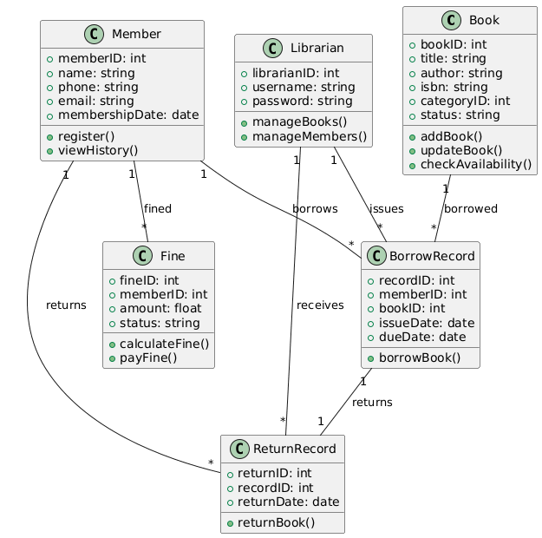

3.2 Sequence Diagram (Borrowing a Book)
1️⃣ Actors / Objects
- Member – requests to borrow a book
- Librarian – processes the request
- System – the LMS software that handles logic
- Database – stores book, member, and transaction records

2️⃣ Steps / Flow
- Member sends a borrow request to the Librarian.
- Librarian asks the System to check if the book is available.
- System queries the Database for book status.
- Database returns the book availability.
- System responds to the Librarian.
- If available, Librarian instructs the System to create a BorrowRecord.
- System stores the record in the Database.
- Database confirms the transaction.
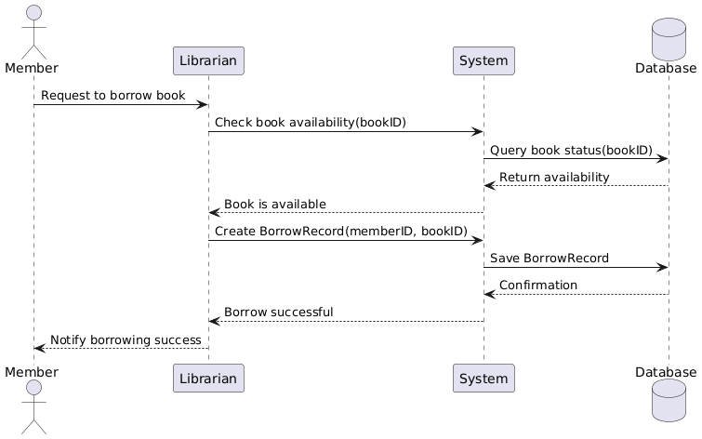

7. Conclusion
The Library Management System helps automate core library operations, reducing manual workload and improving accuracy and efficiency. It ensures that resources are tracked properly, fines are calculated correctly, and transactions are stored securely.

4.concept about git hub

1️⃣ What is GitHub?
GitHub is a cloud-based platform for version control and collaboration, primarily designed for developers but useful for anyone managing files.
- It is built on Git, a distributed version control system created by Linus Torvalds.
- GitHub allows you to store, track, and manage your projects online.
- Each project is stored in a repository, which can include code, documents, images, or any files.
Think of GitHub as a Google Drive for developers, but with advanced version tracking and collaboration features.

2️⃣ Core Concepts of GitHub
a) Git vs. GitHub
- Git: A local tool that tracks file changes on your computer.
- GitHub: An online platform to host Git repositories, collaborate, and share projects.
- You can use Git locally without GitHub, but GitHub provides: cloud storage, collaboration, and project management tools.

b) Repository (Repo)
- A repository is like a project folder.
- It contains your files, folders, and the complete history of changes.
- Can be public (anyone can see) or private (restricted access).

c) Commit
- A commit is a snapshot of your project at a specific point in time.
- Each commit has:
  - A unique ID (hash)
  - A commit message describing the changes
- Allows you to roll back to previous versions if needed.

d) Branch
- A branch is a separate line of development.
- Example: You can create a branch to add a new feature without affecting the main project.
- Once tested, the branch can be merged into the main branch (main or master).

e) Pull Request (PR)
- A pull request is a request to merge your branch changes into another branch.
- Allows code review, discussion, and conflict resolution before merging.
- Essential for teamwork in collaborative projects.

f) Clone
- Cloning means making a copy of a repository from GitHub to your local machine.
- Allows you to work offline and then push changes back to GitHub.

g) Fork
- A fork is a copy of someone else’s repository under your account.
- Useful for contributing to open-source projects without affecting the original repository.

h) Pull
- Pulling updates your local repository with changes from the remote repository.
- Ensures your local files are up-to-date with the team’s changes.

i) Push
- Pushing uploads your local commits to GitHub.
- Makes your changes visible online and shareable with others.

3️⃣ Advantages of GitHub
- Version Control:
  - Tracks every change and allows you to revert to previous versions.
- Collaboration:
  - Multiple developers or students can work on the same project simultaneously.
- Backup and Storage:
  - Your project is stored online, preventing data loss.
- Portfolio Building:
  - Public repositories show your work to potential employers or instructors.
- Open Source Contribution:
  - Easily contribute to other projects or get contributions from the community.
- Project Management:
  - Tools like Issues, Projects, and Wiki help manage tasks, bugs, and documentation.

4️⃣ How GitHub is Used in Assignments
- Upload assignment files (Word, PDFs, source code, diagrams).
- Track versions of your assignment over time.
- Collaborate with team members for group projects.
- Include diagrams, documentation, and reports in one repository.
- Teachers can view submission history, making grading easier.

5️⃣ Summary
GitHub is more than just a file storage service; it’s a complete platform for project management, collaboration, and version control.
- Even for non-programming assignments like reports, diagrams, and documentation, GitHub is extremely useful for tracking versions and maintaining an organized project history.

